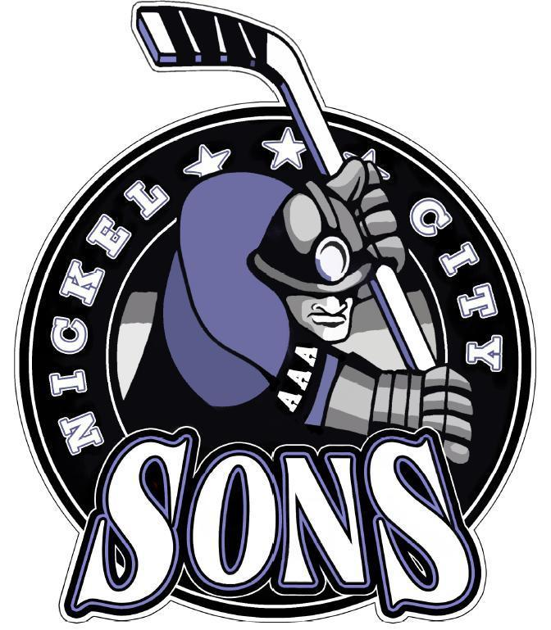

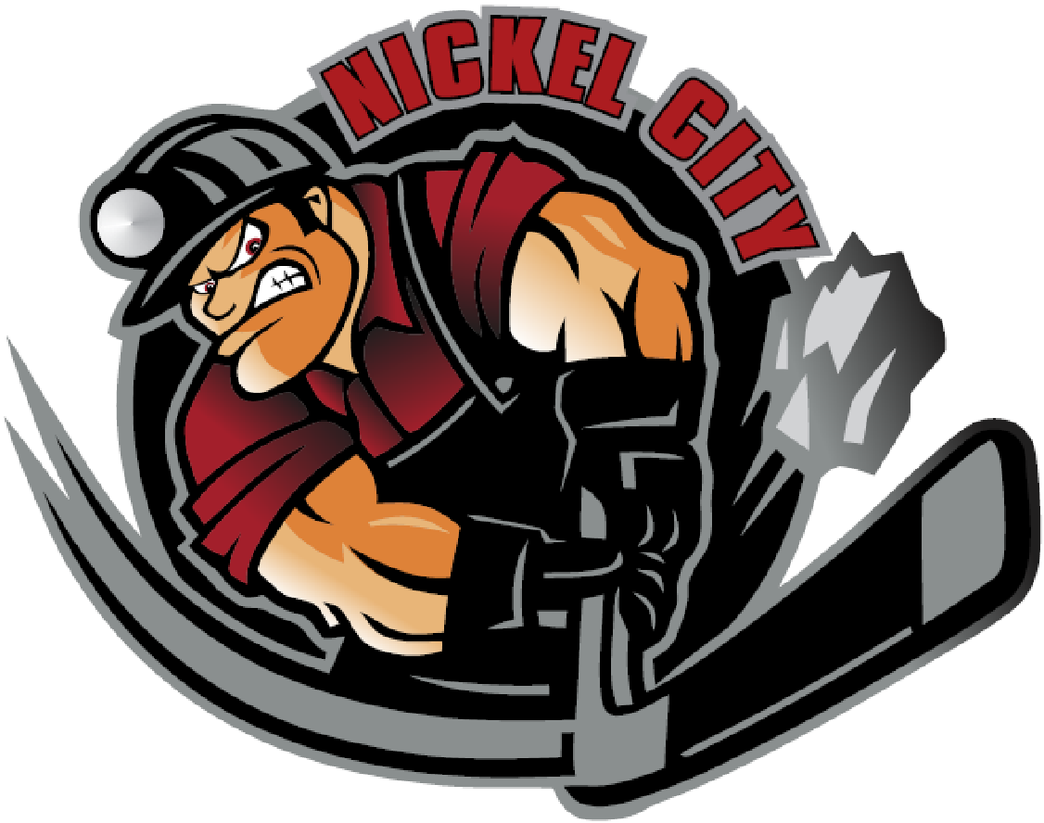**2022-2023 NCHA/SMHA**

**AAA COACHING ANNOUNCEMENT**

Nickel City Hockey Association and Sudbury Minor Hockey Association

are pleased to announce the following coaches:

**U12 AAA – Joey Talbot**

**U13 AAA – Corey Crane**

**U14 AAA – Andrew Dale**

**U15 AAA – Dale Lafrance**

**U16 AAA – Jordan Cheechoo**

**U18 AAA – Brian Dickinson**